UK Year 4 – Pre-test
10 Questions | 30-45 minutes | Calculator not allowed
1. Write a written method to perform the following additions and subtractions.
7890 + 3405 | 3842 + 439
6843 - 3562 | 4391 – 2186
2. Find the rule and complete the following number patterns.

16, 20, 24, ____________, ____________, ____________

18, 27, 36, ____________, ____________, ____________

3. Answer the following questions using knowledge of multiplication and division.
4 kids found some flowers. They picked 5 flowers each.
How many flowers did they pick altogether?
_________________________________________________________________________
The swim team has 3 swimmers racing. They all swim 9 laps each.
How many laps are swum in total?

_________________________________________________________________________
6 kids eat 4 cupcakes each. How many cupcakes are eaten?

_________________________________________________________________________

4. Put these fractions in the correct place on a number line.
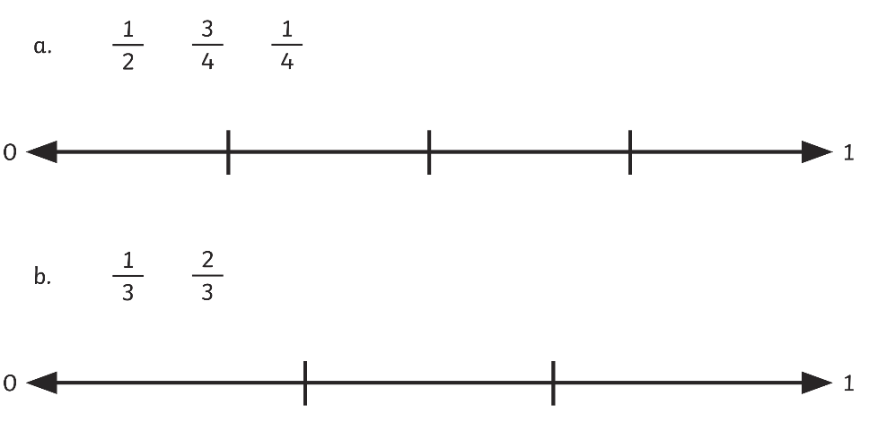

5. Convert time between words 24-hour and 12-hour clocks.
Time in Words | 24 Hour Clock | 12 Hour Clock
12 Past 3 in the morning
 | 21:20
 |  | 4:45 PM
6. Calculate the perimeter of this shape:
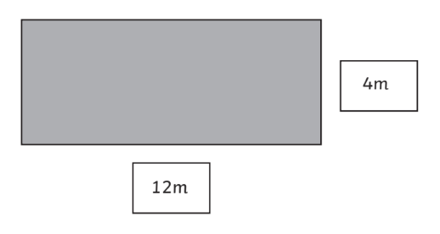
P = _______________________________________

7. Calculate the area of this shape:
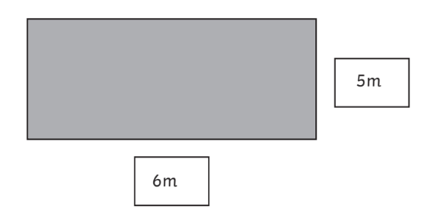
A = _______________________________________

8. Use the line graph to interpret data and answer questions.
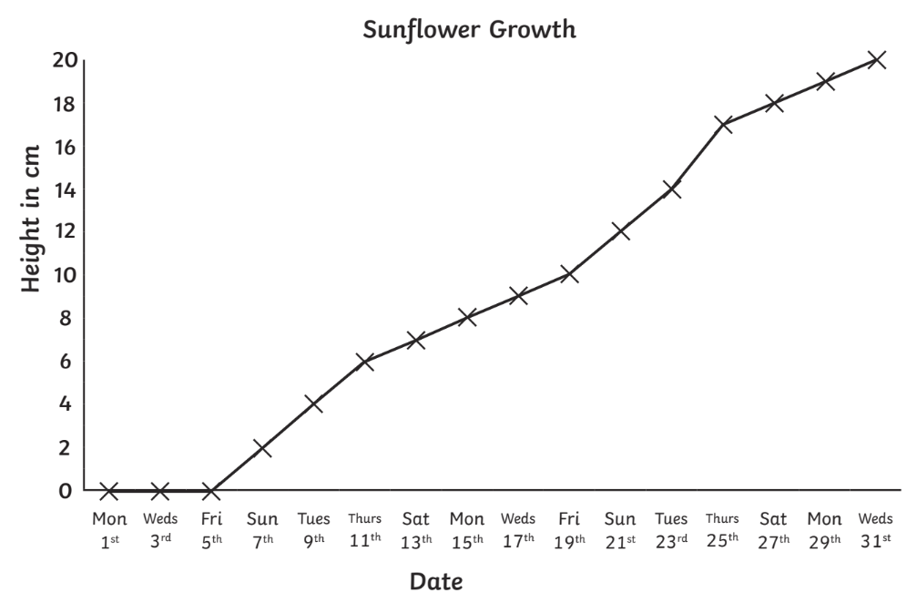
How many days did the plant take to grow 18cm? | ________________
What is the height difference  between Friday 19th and Thursday 25th? | ________________
What is the graph measuring? | ________________

Use the information below to answer questions 9-10.
Dave is working to improve the yard at his house.
9. There are two kinds of soil to choose from.
If brand A is $50 for 5kg and brand B is $48 per 4 kg, which brand is cheaper?

Brand _________________________________ is cheaper.

10. Dave spent 2 hours working in the yard everyday.
If he worked for 24 hours in total, how many days did he work in the yard?

____________________________________ days.

